**Inventory Management System**

**For**

**Methmina Distributors**

Diploma in Software Engineering

DSE182F

Final Project Proposal

|  |  |  |  |
| --- | --- | --- | --- |
|  |  |  |  |
|  |  |  |  |
|  |  |  |  |
|  |  |  |  |
|  |  |  |  |
|  |  |  |  |

National Institute of Business Management - Colombo 7

**Introduction of the Company**

Methmina Distributors (MD) is a wholesale vehicle care products distribution company. The company is located in 444/b/1, Vihara Mawatha, Kothalawala, Kaduwela.

The company import vehicle care products from China and distribute products to buyers.

The following products are imported,

* Pitch Cleaner
* Engine Surface Degreaser
* Pitch Spot Cleaner
* Carnauba Car Wax
* Windshield Washer Additive
* Tire Foam Polish & Cleaner
* Wheel & Rim Cleaner
* Emergency Tyre Weld Puncture Repair
* Plastic Renew Agent
* Multi-purpose Foam Cleaner

And etc.

Usually customers include suppliers and buyers.

Company has few laborers. Some laborers are permanent and others are hired. They use their own vehicle (lorry) and hired vehicles for their products transportation.

Methmina Distributors import and distribute products to buyers. Usually customers include suppliers and buyers.

**Problem Definition**

Currently,

* The company handles manual inventory control system which records Vehicle care products.
* Maintenance equipment and sales in manual system in the form of an Excel sheet. Therefore, we suggested to develop a computerized system for this company. A software system will make the work easier and cost effective than working using Excel sheets.
* Our primary objective is to give handful of solutions to save time and cost incurred in business premises through automated system. By introducing a Software, the problems that companies are facing against this type of recording in sheets will be solved.

**Proposed Solution**

Our Inventory Management System can help eliminate the Manual Process and effectively manage item level inventory movements. The System Design addresses all major challenges of manual count inventory system such as,

* item misplacement
* incorrect identification
* incorrect counting

It enables timely and accurate information for better decision making such as,

* stock reports once a day
* per month
* A year stock allocation and optimize stock availability and as such procuring solutions which can maximized the enterprise profitability.

**Project Scope**

The system intends provide with:

* Login form protection for system and properly logout protection for the user.
* User manual and helping center.
* Division by division password protection.
* Properly password changes option available for login form password and division by division password.

* Maintain customer details

* + - Add new customers.
    - Delete, update & search current customer details.

* Maintain supplier details

* + - Add new suppliers
    - Delete, update and search current supplier details.

* Manage day-to-day transactions and stock details

* + - All items are store in the inventory and properly records all the day-to-day transactions and availability of inventory.
    - Properly maintained customers return items in the database updates.
    - Purchase orders and sales orders are store in the database.
    - Preview the complete or incomplete status of purchase orders.

* Generate Reporting
  + Forecasting Report
  + Payment Reports
  + Sales order and customer reports
  + Purchase order and Supplier reports
  + Stock transaction and availability reports
  + User login reports

* Barcode scanning

➢ Easily identify and track your products; inventory management software integrates with barcode scanners for instant product identification and labeling

* Inventory optimization
  + Maintain just the right amount of inventory for each product, without over - or under- stoking any time. It's especially useful if you deal in products that experience a seasonal rise and fall in demand.

* Stock notifications
  + Receive alerts and notifications when there's over - or under - stoking beyond a defined threshold. This helps you to place orders or offer promotion discounts to clear out extra stock.

* Report generation
  + View sales history in the form of a list of your most popular products. This feature also enables you to manage items in your inventory that have not reached the sales levels you expected, for example, by offering discounts on them.

* Multi location management
  + Manage multiple warehouses and points - of - sale(POS). All location can be integrated within a single inventory management system.

* Material grouping

➢ Group inventory into predefined categories and ensure you're always updated about quantities of components and specifications that make up your product stock, and manage their reordering schedules as required.

* Stock returns handling

➢ Manage returns more effectively by reducing time- to- return through automation of the entire process.

* Purchase order records

➢ Create a single view of purchase order records. You can easily identify which products are in demand, both perpetually and seasonally, and prepare to meet your customers' needs.

**Hardware Requirements**

* Personal Computer with processing power similar or higher than 2.00 GHz.
* RAM with 4 GB or above capacity.
* At least 15 GB or above free Hard Disk space.
* Router, network cable and switch

**Technologies**

* Development Language:
  + - * ASP.NET
      * Java • Database:
      * MYSQL Server
* Tools:
  + - * Visual Studio 2015
      * MYSQL server
      * Adobe Photoshop CS6
      * Adobe Dreamweaver CS6

**Budget and Timeline**

Budget:

|  |  |
| --- | --- |
| **Resource** | **Cost** |
| **Hardware:** |  |
| * Workstation * Server (Database) * Backup Power Supply * Networking Equipment | 80,000  90,000  15,000  8,000 |
| **Software:** |  |
| * Microsoft Windows 10 (Professional) * Windows Server 2014 R2 * MYSQL Server | 18,000  105,000  150,000 |
| **Networking** (work environment)   * Switch * Network cable * Router | 8,000 |
| **Software Development** | 200,000 |
| **Transportation** | 5,000 |
| **Other** | 7,000 |
| **TOTAL** | **Rs. 686,000** |

Timeline:

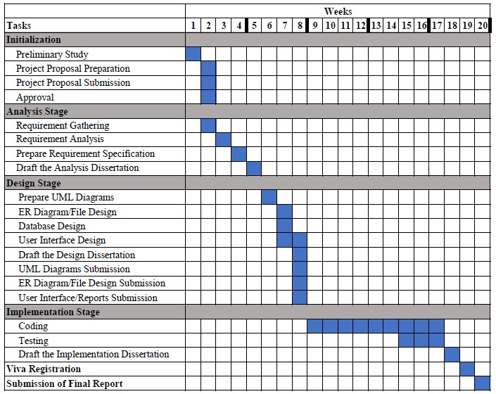

**Software Limitations**

* This software can run only core i3, core i5 and core i7
* This software can run windows 7, 8 and 10
* This software cannot run Android, IOS, and Tab

**Recommendations**

* Reduce costs, improve cash flow, and boost your business's bottom line
* Keep track of your inventory in real time
* Help your forecast demand
* Prevent products and production shortage
* Prevent excess stock and too many raw materials
* Allow for easy inventory analysis on any device
* Be accessible right from your retail point - of – sale
* Optimize warehouse organization and precious employee time
* Offer quick and painless bar code scanning to speed up intake
* Allow for multi-location management, tracking inventory across several locations or warehouse

**Deliverables**

* Inventory management software application
* Source code
* System documentation
* User manual

**Conclusion**

Inventory Management is essential to every company, having inventories. The companies like Spare parts & maintenance equipment need to have stock, but in such amount to avoid out of stock and overstock situations. Inventory Management can improve company’s inventory control existing situation and decrease costs of the company. By a computerized system it can support several forecasting methods and changes to the business environment.

**References**

Data collection methodologies used:

* Conversation with owner of the company and currently data stored documents/records in this company.

* 2146,2180,2173,2154,2158 previous inventory management system projects-

NIBM Library

* Internet as a source of information

* + - * W3School online web tutorials - https://www.w3schools.com/



* + - * Inventory System-<https://youtu.be/m23GVOQgfAk>

* + - * Online Inventory Management Software With PHP, MySQL, Bootstrap Open Source Project-<https://youtu.be/xjsUiLrgIks>

* + - * Inventory Management System in PHP and MySQL with Project files

(READ DESCRIPTION)-<https://youtu.be/Tjl4H6Wfe3U>